Temperature Monitor

Files Needed: [Github](https://github.com/Zhaycub/ServerRoom-TemperatureSensor)

Materials Used:

|  |  |  |
| --- | --- | --- |
| Aluminum rack mount | DS18B20 Temperature Sensor | Raspberry Pi 3.0 |
| 16 x 2 LCD display | Dual-Color LED | Breadboard (mini) |
| 19 Male to female | 9 Jumper Wires | 1 resistor (200 ohms) |
| Hot Glue | Industrial Velcro | 4 female to female |

Pins:

|  |  |
| --- | --- |
|  | 1. Power for the Breadboard |
|  | 1. Power for the Fan |
|  | 1. Ground for the Fan |
| 1. Signal for the sensor |  |
| 1. Ground for the breadboard |  |
| 1. RS for the Display |  |
| 1. Enable for the Display |  |
| 1. D4 |  |
|  |  |
| 1. R for the RG LED |  |
| 1. G for the RG LED | 1. D5 |
|  | 1. D6 |
|  | 1. D7 |

Steps After Assembly:

**First**, check to make sure your sensor is set up correctly:

1. To add support, we first need to open up the boot config file, and this can be done by running the following command:
2. At the bottom of this file enter the following.



1. Once done save & exit by pressing *ctrl x* and then *y*. Now reboot the Pi by running the following command.



1. You can skip to downloading the code onto the Pi or follow the next few steps to check that the sensor is actually working.
2. Once the Raspberry Pi has booted back up, we need to run modprobe so we can load the correct modules.



1. Now change into the devices directory and use ls to see the folder/files in this directory.



1. Now run the following command, change the numbering after cd to what has appeared in your directory by using the ls command. (If you have multiple sensors there will be more than one directory)



1. Now run the following command.



1. It should look like this, make sure that yours says YES: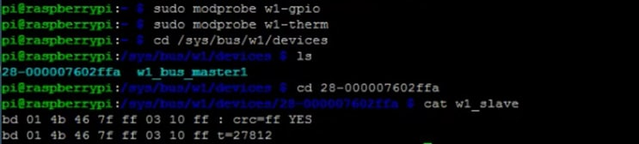

**Second**, prepare the webiopi:

Replace x.y.z with whichever version is currently available



**Third**, get the files sorted:

1. place the webiopi file from the github in /home/pi
2. open the webiopi folder
3. open test01
4. open scripts
5. open script01.py
6. scroll down and set your own threshold for the temperature range
7. scroll down more and set the URI equal to your IP

**Fourth**, go into the command line:



1. After entering the config file go to the doc-root section and change “doc-root = /home/pi/webiopi/examples/scripts/macros” to doc-root = /home/pi/webiopi/test01”, and remove the pound sign at the start of the line
2. Change the welcome-file to “index01.html”, and remove the pound sign
3. Go to the scripts section and change “myscript = /home/pi/webiopi/examples/scripts/macros/script.py” to “myscript = /home/pi/webiopi/test01/scripts/script01.py”
4. Scroll to the devices section and change “#temp2” to “ServerRoom

After completing those steps, save your changes and leave the config file. Now:

$ cd /usr/share/webiopi/htdocs

$ ls

$ sudo nano webiopi.js

1. Find the reference to “getCelsius” the function should look like: “this.getCelsius(function(name, data){“
2. Change “getCelsius” to “getFahrenheit”
3. Change “°C” to “°F”

Now save your changes and leave js file.

**Finally,** start up the command for the website:

$ sudo webiopi –d –c /etc/webiopi/config